Thursday November, 17th, 2016

**Plansavvy user Guide**

Group 13

Tanushree Sharma, Remi Shah, Ishaan Singh, Andy Su, Jane Tong

Table of Contents

Instructions4

1.1 Getting Starting4

1.2 Creating Multiple Timelines6

Features7

2.1 Buttons7

2.1.1 Timeline7

2.1.2 Update8

2.1.3 Sort8

2.1.4 Search9

2.1.5 Move Graph9

2.1.6 Open Calendar9

2.2 Completion Bar9

Additional Notes10

Frequently Asked Questions11

*Welcome to the PlanSavvy User Guide! Thank you for choosing our tool so that we can help you make team projects less of a hassle to coordinate. The PlanSavvy tool will effectively schedule your team project from the day it begins to the day the final deliverable is due. Tired of not knowing what tasks team members have completed? With the PlanSavvy tool you can easily track and visualize the progress of individual group members and the project overall. Happy planning!*

Instructions

1.1: Getting Started

1. Break up the project into equally weighted tasks (Note: the number of tasks are limited to 30 entries).
2. Enter each task under the “Task Name” column (column G). Every task should be entered in its own cell.
3. Update the spreadsheet by clicking the “Update” button found in the lower left corner of the dashboard. For more information about the “Update” button, see the features section.
4. Select the “Start Date” cell directly to the right of a task.
5. Select the “Open Calendar” button found in the lower left corner of the dashboard.
6. Select the predicted start date and end date by navigating through the calendar. Note: The values will automatically update in the corresponding cells. Users can also manually input the start and end dates (YYYY-MM-DD)
7. Enter the name(s) of those responsible for each task in the corresponding cell under the “Responsible” column (column N).
8. To create the Timeline, begin by selecting the “Task” column (Cell G,4). Drag your cursor to highlight cells ranging from column G to column J by using your cursor to drag the highlighted portion to the corresponding cell in column J.

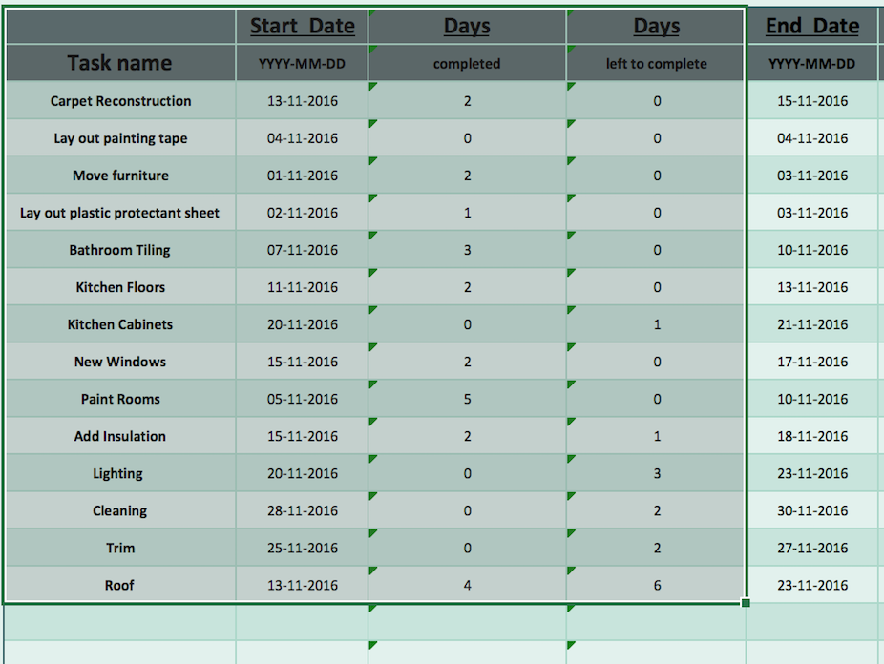

1. Once the required cells are highlighted click on the “Timeline” button found in the lower left corner of the dashboard.
2. Enter a title for your chart and desired scale (eg. 1 day, 2 days, 7 days) for the chart in the popup pane.

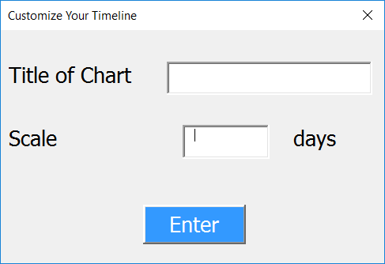

1. The timeline will appear in the current spreadsheet underneath the dashboard interface.

1.2: Creating Multiple Timelines

1. Follow all of the steps highlighted in the “Getting Started” guide.
2. Move the active chart into the “Charts” worksheet by selecting the “Move Graph” button found in the bottom left corner of the dashboard. Note: if the chart active in the main worksheet is not moved to the “Charts” worksheet and the user attempts to create another chart the active chart will be deleted.
3. Sort the data different ways to have the chart display the data in the most useful form. Create as many timelines as desired, keeping in mind to move each chart to the “Charts” worksheet.

Features

2.1: Buttons *(Located on bottom left of the Dashboard)*

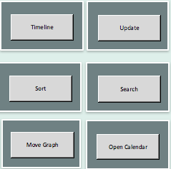

*2.1.1 Timeline*

* A graphic that can easily convey the completion of a task or tasks in order to track the overall progress of the project.
* User is able to select a title for each timeline they create so as not to get multiple mixed up.
* Timeline is customizable, scale can be chosen based on length of the project.
* The x-axis of the chart is the scale (by days) that was previously selected in the popup menu initialized when creating a chart.
* The y-axis is the list of tasks.
* The bars on the chart include the names of the members responsible for each task.
* The bars are dual toned such that the blue portion represents days that have passed and the teal portion represents the remaining days until the task is scheduled to be completed.

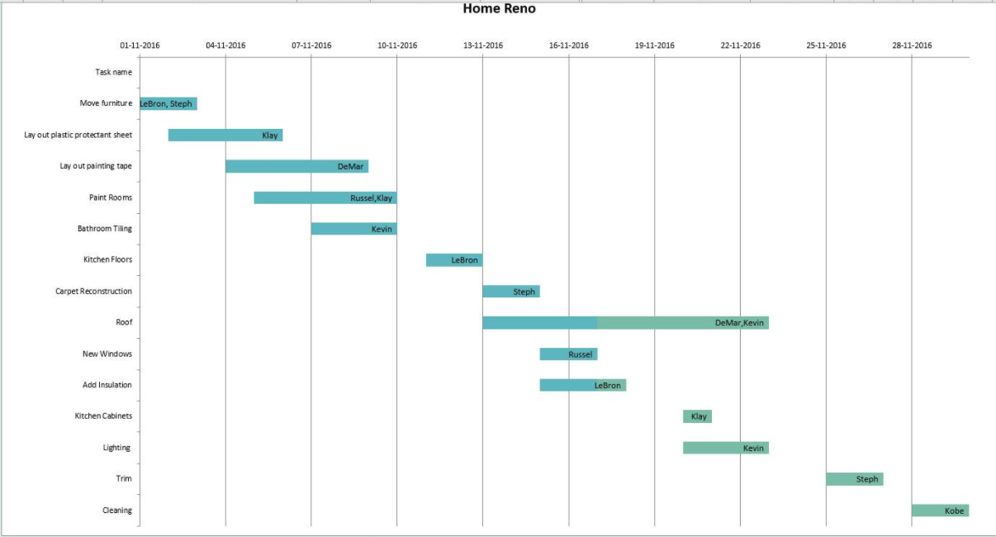

*2.1.2 Update*

* This feature ensures that completion checkboxes appear as new tasks are added.

*2.1.3 Sort*

* Find specific information by searching by person, by task, by start/end date or by completion.
* A popup pane with the desired information will appear once the search method is selected.

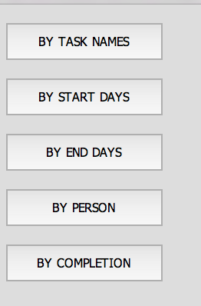

*2.1.4 Search*

* Find specific information by searching by person, by task, by start/end date or by completion.
* A popup pane with the desired information will appear once the search method is selected.

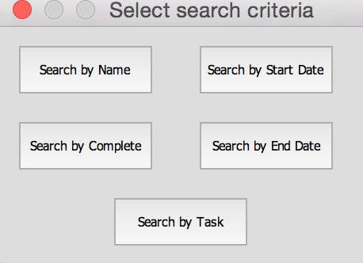

*2.1.5 Move Graph*

* In order to avoid clutter, only one timeline chart can be viewed on the main worksheet. Moving the timeline chart will place the chart into the “Charts” worksheet where multiple charts can be viewed and stored for comparison.

*2.1.6 Open Calendar*

* Opening the calendar allows the user to easily select start and end dates for each task.

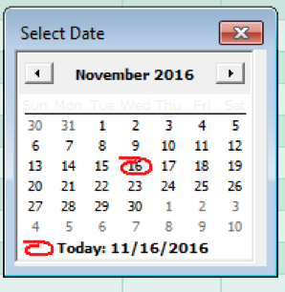

2.2 Completion Bar

* As tasks are checked off when completed, the completion bar on the far right of the dashboard will automatically update.
* Gives users a quick visual representation of the overall progress of the project.

Additional Notes

* Timeline charts are automatically updated if the start and end dates of tasks are changed.
* A new chart is required to be made if another row of data is inputted.
* All entries are case sensitive.
* Tool is optimized for PC users.
* Project duration must be greater than one day.

Frequently Asked Questions

1. Why does my original timeline keep disappearing when I create a new one?

A: Only one timeline can be viewed in the main worksheet. Move the active timeline into the “Charts” worksheet in order to store it. See the “Creating Multiple Timelines” guide for more information.

1. Why are there no completion checkboxes present after I add a task?

A: Update the worksheet after entering new tasks. Completion checkboxes only appear once there is a task in the corresponding cells and the worksheet is updated.

1. Why am I unable to create a timeline?

A: Ensure that the correct range of cells have been chosen. Ensure that start and end dates are selected.

1. Why am I unable to modify certain cells?

A: Some cells are encrypted such that only developers are able to modify them.